UE20CS312 - Data Analytics Worksheet 2b : Multiple Linear Regression

GAURAV MAHAJAN

2022-09-15

###Importing libraries and uploading the dataset

library(tidyverse)

## Warning: package 'tidyverse' was built under R version 4.2.1

## ── Attaching packages ─────────────────────────────────────── tidyverse 1.3.2 ──  
## ✔ ggplot2 3.3.6 ✔ purrr 0.3.4  
## ✔ tibble 3.1.8 ✔ dplyr 1.0.9  
## ✔ tidyr 1.2.0 ✔ stringr 1.4.0  
## ✔ readr 2.1.2 ✔ forcats 0.5.2

## Warning: package 'ggplot2' was built under R version 4.2.1

## Warning: package 'tibble' was built under R version 4.2.1

## Warning: package 'tidyr' was built under R version 4.2.1

## Warning: package 'readr' was built under R version 4.2.1

## Warning: package 'purrr' was built under R version 4.2.1

## Warning: package 'dplyr' was built under R version 4.2.1

## Warning: package 'stringr' was built under R version 4.2.1

## Warning: package 'forcats' was built under R version 4.2.1

## ── Conflicts ────────────────────────────────────────── tidyverse_conflicts() ──  
## ✖ dplyr::filter() masks stats::filter()  
## ✖ dplyr::lag() masks stats::lag()

library(corrplot)

## Warning: package 'corrplot' was built under R version 4.2.1

## corrplot 0.92 loaded

library(olsrr)

## Warning: package 'olsrr' was built under R version 4.2.1

##   
## Attaching package: 'olsrr'  
##   
## The following object is masked from 'package:datasets':  
##   
## rivers

df <- read_csv('spotify.csv')

## Rows: 195 Columns: 13  
## ── Column specification ────────────────────────────────────────────────────────  
## Delimiter: ","  
## dbl (13): danceability, energy, key, loudness, mode, speechiness, acousticne...  
##   
## ℹ Use `spec()` to retrieve the full column specification for this data.  
## ℹ Specify the column types or set `show_col_types = FALSE` to quiet this message.

head(df)

## # A tibble: 6 × 13  
## danceabil…¹ energy key loudn…² mode speec…³ acous…⁴ instr…⁵ liven…⁶ valence  
## <dbl> <dbl> <dbl> <dbl> <dbl> <dbl> <dbl> <dbl> <dbl> <dbl>  
## 1 0.803 0.624 7 -6.76 0 0.0477 0.451 7.34e-4 0.1 0.628   
## 2 0.762 0.703 10 -7.95 0 0.306 0.206 0 0.0912 0.519   
## 3 0.261 0.0149 1 -27.5 1 0.0419 0.992 8.97e-1 0.102 0.0382  
## 4 0.722 0.736 3 -6.99 0 0.0585 0.431 1.18e-6 0.123 0.582   
## 5 0.787 0.572 1 -7.52 1 0.222 0.145 0 0.0753 0.647   
## 6 0.778 0.632 8 -6.42 1 0.125 0.0404 0 0.0912 0.827   
## # … with 3 more variables: tempo <dbl>, duration_ms <dbl>,  
## # time_signature <dbl>, and abbreviated variable names ¹​danceability,  
## # ²​loudness, ³​speechiness, ⁴​acousticness, ⁵​instrumentalness, ⁶​liveness  
## # ℹ Use `colnames()` to see all variable names

###Problem-1 (0.5 Points) Check for missing values in the dataset and normalize the dataset.

#checking for missing values  
sum(is.na(df))

## [1] 0

#Normalisation  
min_max_norm <- function(x) {  
 (x - min(x)) / (max(x) - min(x))  
}  
df_norm <- as.data.frame(lapply(df, min_max_norm))

This implies there is no missing data in the dataset

#for scaling :   
#for z score scaling to be done centering is done  
df<-as.data.frame(scale(df))

###Problem-2 (2 Points) Fit a linear model to predict the energy rating using all other attributes.Get the summary of the model and explain the results in detail.[Hint : Use the lm() function. Click here To get the documentation of the same.]

#For all the attributes fitting a linear model  
full_model<-lm(energy~.,data = df)  
summary(full_model)

##   
## Call:  
## lm(formula = energy ~ ., data = df)  
##   
## Residuals:  
## Min 1Q Median 3Q Max   
## -1.00232 -0.22889 -0.00973 0.27796 1.24597   
##   
## Coefficients:  
## Estimate Std. Error t value Pr(>|t|)   
## (Intercept) 9.156e-17 2.920e-02 0.000 1.00000   
## danceability -2.751e-01 5.555e-02 -4.952 1.67e-06 ***  
## key 4.970e-02 3.009e-02 1.652 0.10030   
## loudness 7.015e-01 4.561e-02 15.381 < 2e-16 ***  
## mode -4.794e-02 3.034e-02 -1.580 0.11582   
## speechiness 2.359e-02 3.519e-02 0.670 0.50343   
## acousticness -3.435e-01 4.136e-02 -8.306 2.21e-14 ***  
## instrumentalness 1.493e-01 5.577e-02 2.677 0.00811 **   
## liveness 2.004e-02 3.100e-02 0.646 0.51880   
## valence 2.046e-01 3.884e-02 5.269 3.85e-07 ***  
## tempo -2.395e-02 3.295e-02 -0.727 0.46817   
## duration_ms -1.865e-02 3.303e-02 -0.565 0.57298   
## time_signature 2.409e-02 3.220e-02 0.748 0.45535   
## ---  
## Signif. codes: 0 '***' 0.001 '**' 0.01 '*' 0.05 '.' 0.1 ' ' 1  
##   
## Residual standard error: 0.4077 on 182 degrees of freedom  
## Multiple R-squared: 0.844, Adjusted R-squared: 0.8338   
## F-statistic: 82.08 on 12 and 182 DF, p-value: < 2.2e-16

The asterisks tell us the significance .If alpha is 0.05 :: we select : danceability , loudness , acousticness , instrumentalness , valence according to this model.Betas are not all zero seeing he F statistic

###Problem-3 (2 points) With the help of a correlogram and scatter plots, choose the features you think are important and model an MLR. Justify your choice and explain the new findings.

df_cor <- cor(df_norm)  
corrplot(df_cor, order = "hclust", method = "number")

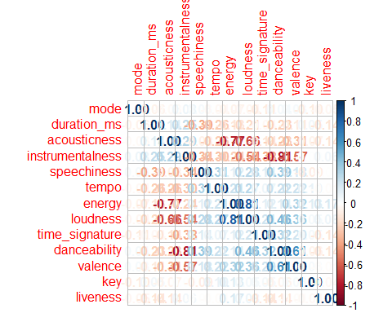

plot(df_norm)

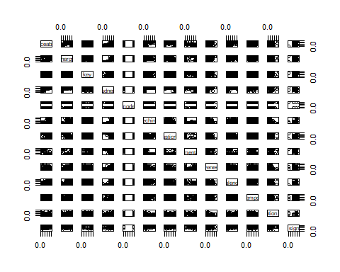

#energy has significant positive correlation with loudness, valence and tempo  
#energy has significant negative correlation with acousticness, instrumentalness  
#these variables are significant in the model  
  
model_cor <- lm(energy~loudness+acousticness+valence+tempo+instrumentalness, data=df_norm)  
summary(model_cor)

##   
## Call:  
## lm(formula = energy ~ loudness + acousticness + valence + tempo +   
## instrumentalness, data = df_norm)  
##   
## Residuals:  
## Min 1Q Median 3Q Max   
## -0.29492 -0.07908 0.00527 0.08305 0.33311   
##   
## Coefficients:  
## Estimate Std. Error t value Pr(>|t|)   
## (Intercept) -0.282319 0.080630 -3.501 0.000577 ***  
## loudness 1.111635 0.077476 14.348 < 2e-16 ***  
## acousticness -0.294210 0.035350 -8.323 1.69e-14 ***  
## valence 0.123858 0.036325 3.410 0.000795 ***  
## tempo -0.003382 0.037722 -0.090 0.928645   
## instrumentalness 0.230480 0.032243 7.148 1.86e-11 ***  
## ---  
## Signif. codes: 0 '***' 0.001 '**' 0.01 '*' 0.05 '.' 0.1 ' ' 1  
##   
## Residual standard error: 0.1154 on 189 degrees of freedom  
## Multiple R-squared: 0.8108, Adjusted R-squared: 0.8058   
## F-statistic: 162 on 5 and 189 DF, p-value: < 2.2e-16

###Problem-4 (1 Point) Conduct a partial F-test to determine if the attributes not chosen by you in Problem-3 are significant to predict the energy.What are the null and alternate hypotheses? [ Hint : Use the anova function between models created in Problem-2 and Problem-3 ]

anova(model_cor,full_model)

## Analysis of Variance Table  
##   
## Model 1: energy ~ loudness + acousticness + valence + tempo + instrumentalness  
## Model 2: energy ~ danceability + key + loudness + mode + speechiness +   
## acousticness + instrumentalness + liveness + valence + tempo +   
## duration_ms + time_signature  
## Res.Df RSS Df Sum of Sq F Pr(>F)  
## 1 189 2.5151   
## 2 182 30.2566 7 -27.741

###Problem-5 (1.5 Points) AIC - Akaike Information Criterion is used to compare different models and determine the best fit for the data. The best-fit model according to AIC is the one that explains greatest amount of variation using the fewest number of attributes. Check this resource to learn more about AIC. Build a model based on AIC using Stepwise AIC regression.Elucidate your observations from the new model. ( Hint : Use an appropriate function in olsrr package.)

stepwise_model<-lm(energy ~ loudness + acousticness + danceability + valence + instrumentalness + mode + key , data=df)  
summary(stepwise_model)

##   
## Call:  
## lm(formula = energy ~ loudness + acousticness + danceability +   
## valence + instrumentalness + mode + key, data = df)  
##   
## Residuals:  
## Min 1Q Median 3Q Max   
## -1.05662 -0.24874 -0.01126 0.27930 1.25974   
##   
## Coefficients:  
## Estimate Std. Error t value Pr(>|t|)   
## (Intercept) 9.999e-17 2.900e-02 0.000 1.00000   
## loudness 7.075e-01 4.462e-02 15.856 < 2e-16 ***  
## acousticness -3.420e-01 4.005e-02 -8.539 4.63e-15 ***  
## danceability -2.681e-01 5.308e-02 -5.051 1.04e-06 ***  
## valence 2.003e-01 3.825e-02 5.238 4.35e-07 ***  
## instrumentalness 1.418e-01 5.351e-02 2.650 0.00873 **   
## mode -4.863e-02 2.985e-02 -1.629 0.10491   
## key 4.488e-02 2.950e-02 1.521 0.12988   
## ---  
## Signif. codes: 0 '***' 0.001 '**' 0.01 '*' 0.05 '.' 0.1 ' ' 1  
##   
## Residual standard error: 0.4049 on 187 degrees of freedom  
## Multiple R-squared: 0.842, Adjusted R-squared: 0.8361   
## F-statistic: 142.3 on 7 and 187 DF, p-value: < 2.2e-16

###Problem-6 (1 Point) Plot the residuals of the models built till now and comment on it satisfying the assumptions of MLR.

plot(full_model$residuals , pch = 16, col="red")  
abline(h=0,lty=2)

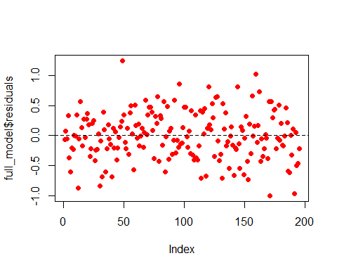

ols_plot_resid_hist(full_model)

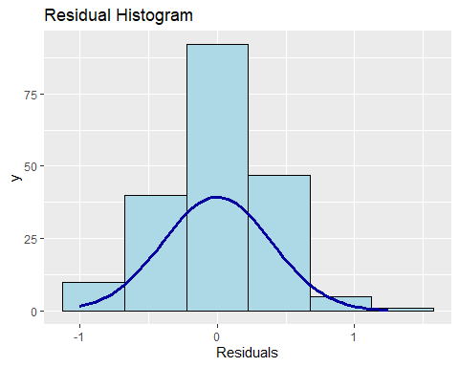

plot(model_cor$residuals , pch = 16, col="red")  
abline(h=0,lty=2)

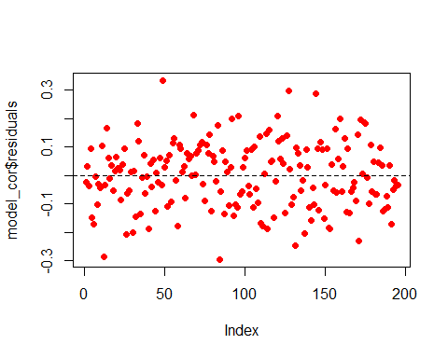

ols_plot_resid_hist(model_cor)

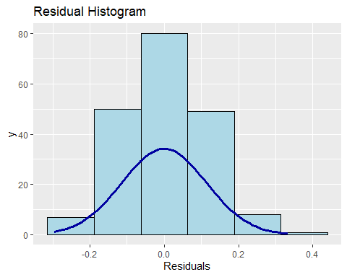

Problem-7 (2 Points) For the model built in Problem-2 , determine the presence of multicollinearity using VIF. Determine if there are outliers in the data using Cook’s Distance. If you find any , remove the outliers and fit the model for Problem-2 and see if the fit improves. [ Hint : All the relevant functions can be found in olsrr package. An observation can be termed as an outlier if it has a Cook’s distance of more than 4/n where n is the number of records.]

ols_vif_tol(full_model)

## Variables Tolerance VIF  
## 1 danceability 0.2776703 3.601393  
## 2 key 0.9467671 1.056226  
## 3 loudness 0.4119898 2.427245  
## 4 mode 0.9308390 1.074300  
## 5 speechiness 0.6921660 1.444740  
## 6 acousticness 0.5009458 1.996224  
## 7 instrumentalness 0.2755568 3.629016  
## 8 liveness 0.8914397 1.121781  
## 9 valence 0.5680642 1.760364  
## 10 tempo 0.7892957 1.266952  
## 11 duration_ms 0.7855373 1.273014  
## 12 time_signature 0.8262918 1.210226

cooks <- ols_plot_cooksd_chart(full_model)

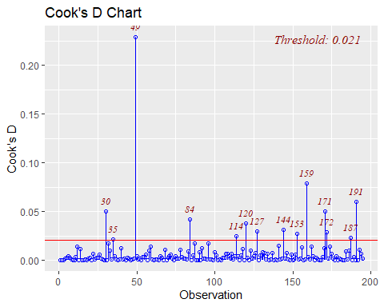

new_df<-df[-c(30,35,49,84,114,120,127,144,153,159,171,172,187,191),]  
new_full_model<-lm(energy~.,data=new_df)  
summary(new_full_model)

##   
## Call:  
## lm(formula = energy ~ ., data = new_df)  
##   
## Residuals:  
## Min 1Q Median 3Q Max   
## -0.76364 -0.20836 0.01581 0.23506 0.95145   
##   
## Coefficients:  
## Estimate Std. Error t value Pr(>|t|)   
## (Intercept) -0.001128 0.025283 -0.045 0.964458   
## danceability -0.258483 0.052291 -4.943 1.85e-06 ***  
## key 0.088181 0.026094 3.379 0.000903 ***  
## loudness 0.838411 0.045399 18.468 < 2e-16 ***  
## mode -0.012666 0.026559 -0.477 0.634036   
## speechiness -0.004528 0.032087 -0.141 0.887947   
## acousticness -0.280188 0.037293 -7.513 3.26e-12 ***  
## instrumentalness 0.199483 0.051442 3.878 0.000151 ***  
## liveness 0.028416 0.027232 1.043 0.298230   
## valence 0.187216 0.033329 5.617 7.90e-08 ***  
## tempo -0.018193 0.029627 -0.614 0.540008   
## duration_ms -0.059788 0.028685 -2.084 0.038647 *   
## time_signature 0.036680 0.028430 1.290 0.198761   
## ---  
## Signif. codes: 0 '***' 0.001 '**' 0.01 '*' 0.05 '.' 0.1 ' ' 1  
##   
## Residual standard error: 0.337 on 168 degrees of freedom  
## Multiple R-squared: 0.8778, Adjusted R-squared: 0.8691   
## F-statistic: 100.6 on 12 and 168 DF, p-value: < 2.2e-16